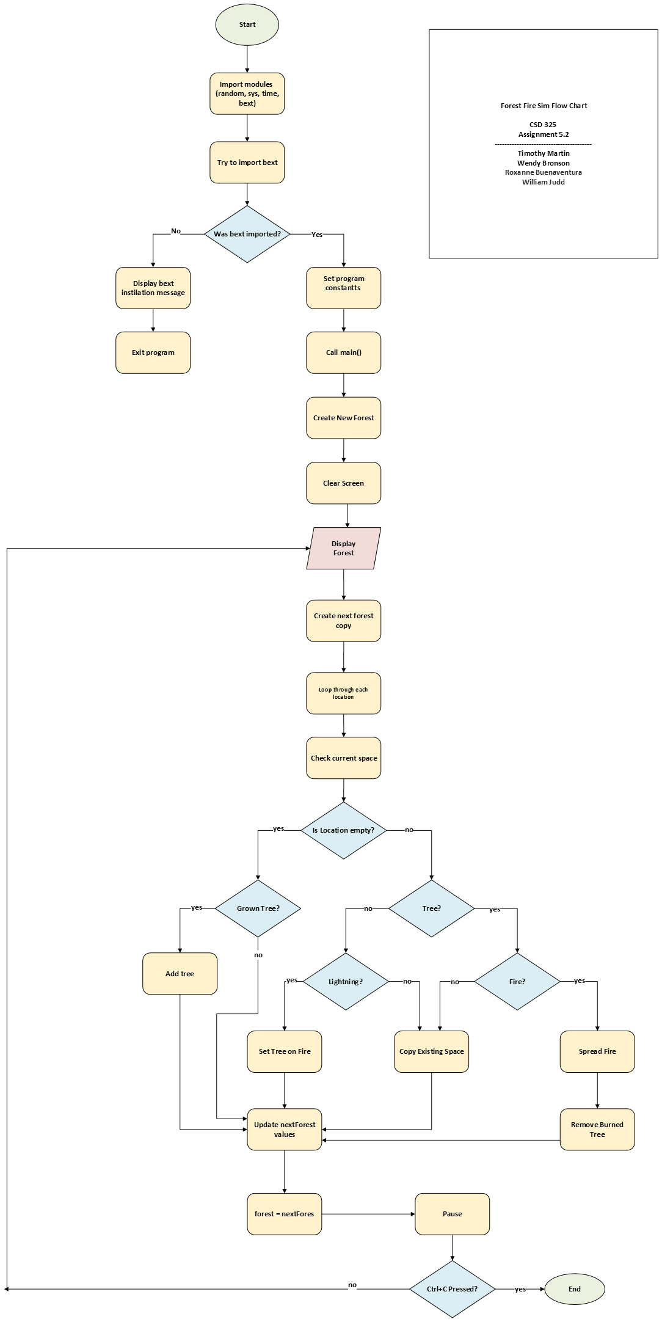
Assignment 5.2: Forest Fire Sim Group D
CSD 325
June 28, 2026
Timothy Martin
Wendy Bronson
Roxanne Buenaventura
William Judd
ForestFireSimFlow.vsdx

